Surrey Hills coffee roastery receives international B Corp sustainability accreditation

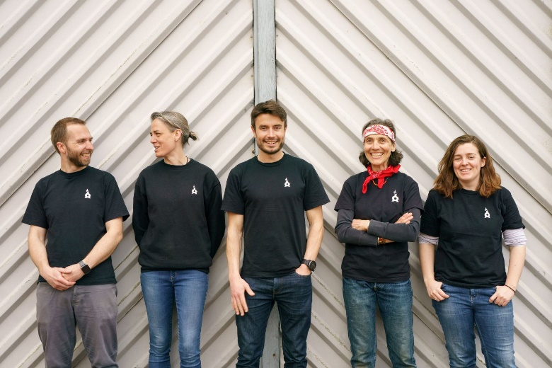
Photo: The Chimney Fire Coffee team with founder Dan Webber (centre) at their Surrey Hills roastery near Dorking

A speciality coffee roastery in the Surrey Hills has become one of only 700 businesses in the UK to be awarded B Corp status, an international commendation of its social and environmental performance.

Celebrating its fifth anniversary, Chimney Fire Coffee near Dorking was founded in 2017 and has become Surrey’s fastest growing coffee roastery - offering a range of whole bean, ground and pod coffee in fully compostable packaging to consumers and coffee shops, as well as bean to cup tasting experiences.

“I started Chimney Fire Coffee with the ambition of making speciality coffee more accessible to a wider audience while also maintaining sustainable business practices, so it’s gratifying to be recognised with B Corp certification,” says Chimney Fire Coffee founder Dan Webber, who worked in coffee and cocoa traceability and ethical supply chain analysis before launching his business.

“We wanted to make sure that sustainability was an absolutely integral part of our philosophy at every stage of Chimney Fire Coffee – from the sourcing, packing and delivery of our coffee to the charities and events we support.”

As well as building direct relationships with farmers and paying on average 90% over Fairtrade base rates for their coffee, Chimney Fire Coffee donate a percentage of Discovery Coffee sales to Re-Cycle, a charity who refurbish bikes in the UK and send them to rural communities in Africa.

To celebrate its fifth anniversary, Chimney Fire Coffee has added an extra special Kenya Vava coffee to its core range and a brand-new Espresso Martini cold brew cocktail collaboration with fellow Surrey Hills business Silent Pool Distillers will be released this summer.

- For more information, please contact Chimney Fire Coffee founder Dan Webber on dan@chimneyfirecoffee.com or 01483 664154. Hi-res images of the roastery, team and products are available. Interviews and coffee samples can be arranged by request.

About Chimney Fire Coffee
- Founded in 2017, Chimney Fire Coffee is based at Ranmore Common, Dorking in the Surrey Hills Area of Outstanding Natural Beauty. As well as supplying and training coffee shops and offices around the south-east and London, Chimney Fire Coffee’s range is available to buy via their website and subscription service and delivered direct to homes. For more information, visit https://chimneyfirecoffee.com.
- You can read more in-depth information about Chimney Fire Coffee’s sustainability and ethics here: https://chimneyfirecoffee.com/pages/sustainability-ethics

Notes for the editor:

- Chimney Fire Coffee’s range includes eight core coffees, a rolling monthly 'Discovery Coffee' (where each month they introduce a new and interesting coffee from around the world) and, most recently, Nespresso® compatible compostable coffee pods. Their speciality coffees are competitively priced from £7.50 to £13.50 / 250g with free UK tracked delivery.
- B Corp Certification is a designation that a business is meeting high standards of verified performance, accountability, and transparency on factors from employee benefits and charitable giving to supply chain practices and input materials: https://www.bcorporation.net/en-us/certification
- They also offer popular bean to cup coffee emersion tours at the Chimney Fire Coffee roastery, as well as off-site coffee experiences.
- Chimney Fire Coffee regularly collaborate with other talented local brands and makers and create new products including, for example, cycle jerseys, coffee-chocolate and coffee candles.
- Keen advocates of outdoor sports and the lifestyle, Chimney Fire Coffee support (and often participate in!) Surrey Hills cycling challenges and trail runs.
- Chimney Fire Coffee donate to Re-Cycle, a small charity who refurbish bikes in the UK and send them to rural communities in Africa, with 25p from every 250g bag and £1 from every 1kg bag of all Discovery Coffee sales donated to the charity. So far, Re-Cycle have helped increase school attendance by 30% and donated over 112,000 bikes to Africa. Since 2020, Chimney Fire Coffee has raised more than £4,000 for the charity to date, enabling Re-Cycle to refurbish 140 bikes from the UK and distribute them to rural communities in Africa.
- Later this year, Chimney Fire Coffee will again be launching their popular Twelve Coffees of Christmas gift set, which features all 12 of 2022’s Discovery range coffees packed into one beautiful box.

