Test and Trace & Local Outbreak Control Plan

Keep Surrey Safe Communications Toolkit for businesses 27 July 2020

Dear Business Owners and Managers,

Surrey County Council has launched a phased communication campaign entitled ‘Keep Surrey Safe’ to raise awareness that everyone who has symptoms of Coronavirus can now get tested and that if they test positive they need to share contacts with NHS Test and Trace to stop the spread of the virus. By continuing to follow safety guidelines and engaging in Test and Trace, we can all play our part to Keep Surrey safe and avoid local lockdowns.

We are keen to work with you to support the Government’s Test and Trace programme so that life can start to get back to normal and that our businesses can thrive again.

To support you to spread the word, we have produced the following communication materials for your use. Please email us at surreymatters@surreycc.gov.uk if you require any of these materials in alternative formats.

- An Employer’s guide to Test and Trace
- Editorial for your all staff emails, intranets and/ or internal publications
- Infographic about Test and Trace to accompany the above
- Social Media assets
- A4 Digital Poster to print and display – attachment in email.

More Information:

- Testing and Surrey’s Local Outbreak Control Plan is available on our website: https://www.surreycc.gov.uk/people-and-community/emergency-planning-and-community-safety/coronavirus/coronavirus-testing

- There is also Government advice on support for businesses that you might find useful here:-
- Reopen your business safely during coronavirus (COVID-19) https://www.gov.uk/coronavirus-business-reopening
- Find out how to apply for a grant if you’re self employed https://www.gov.uk/guidance/claim-a-grant-through-the-coronavirus-covid-19-self-employment-income-support-scheme
- Find out what financial support schemes you may be eligible for
https://www.gov.uk/business-coronavirus-support-finder

- Please follow our social media and news channels for up to date Surrey information: -

- Surrey News for updates https://news.surreycc.gov.uk/author/surreynews/

- Surrey County Council Facebook and Surrey Matters Twitter and Facebook

We hope this is useful. Thank you for helping us to keep Surrey safe and open for business.

Kind regards

Surrey County Council Communications Team

An Employer’s guide to Test and Trace

Surrey County Council is here to support Surrey’s businesses to ensure a safe recovery from the COVID-19 pandemic. By working together to support the NHS’s Test & Trace programme we can slow the spread of the virus, ensure that life will start to get back to normal and that our businesses can thrive again.

We’re appealing to employers to play their part by following the latest Government advice on how to work safely during Coronavirus and to help spread the word about Test and Trace. By ensuring working conditions are safe, businesses can also reduce the risk of many employees having to self-isolate and the disruption that follows, if a member of staff tests positive for COVID-19.

What you need to do:
- Follow the latest government advice which explains how to work safely in a range of workplaces and situations
- Consider situations which may lead to infections spreading including:
  - areas where social distancing may be challenging e.g. changing rooms, smoking shelters, canteens and break out rooms
  - car sharing
  - staff working with symptoms to avoid losing their wages
- Plan for how you would operate if a number of staff were self-isolating
- Ensure employees self-isolate immediately if they have any Coronavirus symptoms and get tested straight away, as this needs to be done in the first five days of having symptoms
- Ensure employees self-isolate for seven days if they have Coronavirus symptoms, or if they have been contacted by NHS Test and Trace due to coming in close contact with a case, they must self-isolate for 14 days. This will help stop the spread in your workplace and community
- Support staff to work from home if they feel able
- Direct employees to the Government’s advice about what will happen to their pay whilst isolating and to your own sickness procedures
- If you are made aware of more than one confirmed case of Coronavirus in your workplace (whether by employees, visitors or NHS Test and Trace), employers should contact PHE Surrey and Sussex’s Health Protection Team on 0344 225 3861 (Option 3) for help and advice. They will support you by assessing the risks and identifying the appropriate steps to take
- Help us to spread the word, not the virus - share our posters, website and content in your newsletters and on intranets to ensure staff are well-informed and know what to do
- Continue to play your part in protecting Surrey by preventing the spread and a second lockdown so we can all prosper again.

More information about the Test and Trace programme is available on Surrey County Council’s website. Thank you for helping us to keep Surrey safe and open for business.

Editorial for employees

Play your part to keep our workplaces safe during COVID-19
Here at [insert business name] we are following the latest government advice which outlines how to work safely and keep staff and customers safe.

One major development which can help is the introduction of Test and Trace – the system that enables the NHS to alert those who have been in contact with someone who has tested positive for Coronavirus. Not only does this help stop the spread of the virus, it also provides information that will help an outbreak to be spotted as soon as it happens, so that we can all work together to start to get it under control.

By working together to support the NHS’s Test and Trace programme we can slow the spread of the virus, ensure that life will start to get back to normal and that our businesses can thrive again.

We will help play our part by:

- Supporting you to self-isolate if you have any Coronavirus symptoms – please do not come into the workplace. This will stop the spread amongst your colleagues and our wider community.
We also need you to play your part:
- Got symptoms? Please get tested straight away – anyone is entitled to a free test which needs to be done in the first five days of symptoms
- Self-isolate for seven days if you have symptoms, or if you have been contacted by NHS Test and Trace and identified as having been in close contact of a case, the self-isolation period is 14 days. Do not come to work
- If you test positive for Coronavirus, please share the details of anyone you've been in contact with when contacted by NHS Test and Trace who will then advise individuals about self-isolating
- Familiarise yourselves with the Government’s advice about pay whilst self-isolating and our own sickness procedures [insert link here]
- Help us to spread the word, not the virus – visit Surrey County Council’s coronavirus web pages for more information about staying safe.

Test and Trace is the best way we have to prevent a second wave in Coronavirus infection rates and to ensure a safe recovery for Surrey. If we all play our part by continuing to follow public health advice and complying with NHS Test and Trace instructions, we can prevent the spread of Coronavirus and keep Surrey both safe and back open for business.

Infographic

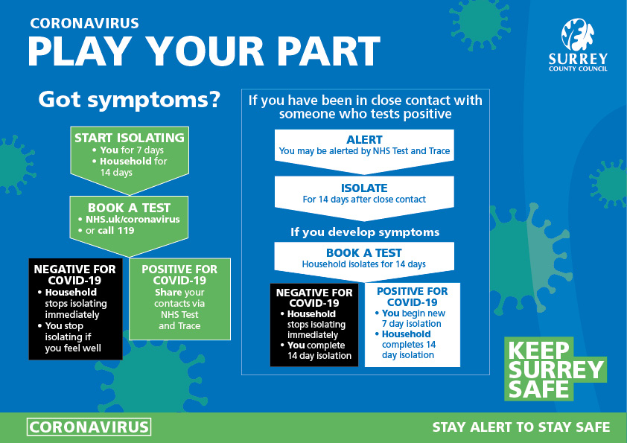

Social Media

FACEBOOK AND INSTAGRAM

Strapline:-
Play your part to keep Surrey safe and avoid a local lockdown with these 5 things. 1. Keep your distance. 2. Wear face coverings where appropriate. 3. Symptoms? self isolate and get tested 4. If you test positive share your contacts with Test and Trace 5. Keep washing those hands.
More information surreycc.gov.uk/coronavirustesting

TWITTER

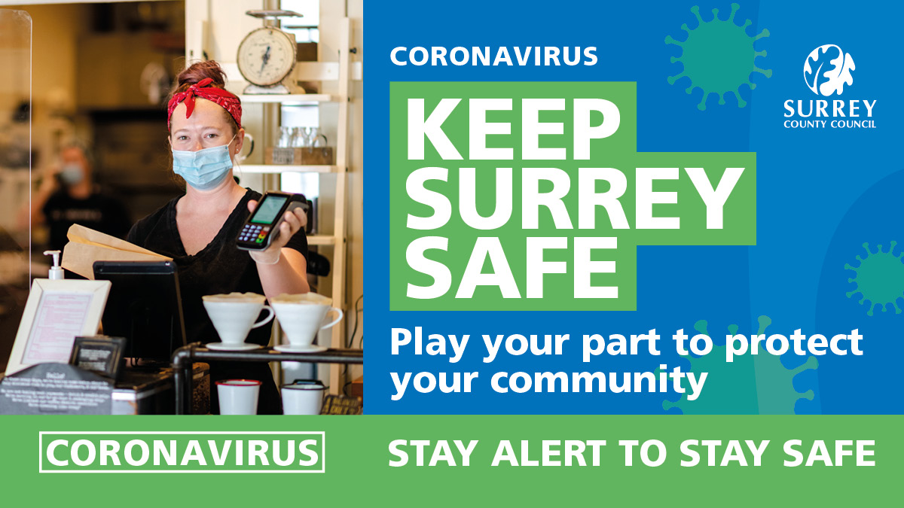

Strapline:-
Play your part to keep Surrey safe and avoid a local lockdown with these 5 things. 1. Keep your distance. 2. Wear face coverings where appropriate. 3. Symptoms? self-isolate and get tested 4. If you test positive share your contacts with Test and Trace 5. Keep washing those hands.
More information surreycc.gov.uk/coronavirustesting

