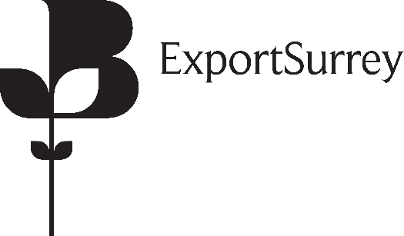

INTERNATIONAL TRADE NOTICE

Preference and non-Preference Certificates of Origin- No Deal Brexit
The British Chambers of Commerce and the accredited Chamber Network continue to work to avoid a messy and disorderly exit from the European Union on 29th March. However, businesses need answers they can base decisions on, no matter the outcome. This includes the trade documentation for use by exporters to prove origin.

Should the United Kingdom reach a Withdrawal Agreement with the EU, then the existing documents that you currently issue will continue to be used throughout any period of transition.

As part of our contingency planning for a no-deal Brexit, our colleagues at the British Chambers of Commerce have worked closely with HMRC and the DIT on revised format of preference and non-preference Certificates of Origin.

In the event of a no-deal Brexit, we have made preparations to enable us to provide you with continuity of service through the issuance of revised ‘United Kingdom’ documentation. This will be ready and available in time for March 29th. If you hold any blank certificates for printing at your business premises then please let us know how many Certificates you are holding and we will arrange a supply of replacement certificates to be issued closer to the 29th March.

The replacement certificates should only be used in the event that the United Kingdom leaves the European Union in a no-deal scenario.

Date: 15th February 2019
If you do have any questions, please feel free to contact us.

Kind Regards

Gary Hayes
International Trade Manager
Notice number: 0031 (15/02)

Surrey Chambers of Commerce
Unit 14a Monument Way East
Woking, Surrey
GU21 5LY

01483 735540
export@surrey-chambers.co.uk

